New York University Medical Center
Department of Medicine
Clinical Pathological Conference

Friday July 20th, 2007 at 11:30 AM
Bellevue Hospital – 17W Conference Room

Moderator: Anthony Grieco, M.D.
Discussant: David Chong, M.D.
Radiologist: David Naidich, M.D.
Wrap-up: Kartikya Ahuja, M.D.

The clinical pathological conference is a teaching exercise in which the students integrate their understanding of patho-physiology and the clinical manifestations of disease with their ability to interpret information provided by a case record. The case is one in which careful consideration of the information available can lead to a correct diagnosis and an insight into the disease process.

The students must submit a complete diagnosis indicating the entity, as well as the manifestations in the patient. All infectious diagnoses must include reference to the etiologic agent by genus and species. Malignant diagnoses must contain enough specificity of cell type to eliminate ambiguity. Cardiac diagnoses must be complete and conform to the New York Heart Association criteria. If a diagnostic procedure was performed, the diagnosis must include the proposed procedure.

Selected students will present their diagnosis and reasoning at the CPC on Friday, June 20th 2007. A review of the literature is not expected, but pertinent references should be used. Student presentations are limited to five minutes.

Chief Complaint:
A 45 year old Chinese male presents with chest pain and dyspnea for 10 days.

History of Present Illness:
The patient’s history begins at age 20 when he began to smoke 1 pack of cigarettes daily. He continues to smoke presently.

At age 25 he was hospitalized in China for “fluid in the lungs” and a “chest infection.” He reports he received antibiotics that required hospitalization for six months, and made a full recovery.

At age 38 he immigrated to the United States and worked in a restaurant. The same year he was diagnosed with peptic ulcer disease requiring a partial gastrectomy which was performed without complication.

He was in his usual state of good health until 10 days prior to admission when he began to feel pleuritic chest pain, dyspnea and fevers. He also reported a non-productive cough. No rigors. He sought treatment from a local health care practitioner who prescribed a Chinese herb. The patient took the herb for several days without alleviation of symptoms. His symptoms worsened, now associated with increasing fatigue. He reports no sick contacts, recent travel, headaches, dysuria, abdominal pain, nausea, vomiting nor diarrhea. The dyspnea was worsening, and the patient presented to Bellevue Hospital Center for further care.

Past Medical History: as per HPI
Past Surgical History: as per HPI

Medications: An unknown Chinese herb for one week
Allergies: none

Family History: Father alive with history of CVA, Mother alive with no known medical history

Social History:
Born in China. No alcohol use. No elicit drug use. Lives with a friend. Not married. Sexually active with a female

Review of Systems: otherwise negative.

Physical Exam:
General: well developed man in acute respiratory distress and diaphoretic
BP 106/74, HR 103 and regular, RR 24, Temp 99.6, oxygen saturation 94% on room air
Oropharynx clear
No lymphadenopathy
JVD to mandible
No rashes
Lungs clear
Tachyardic, regular, no murmurs
Normal bowel sounds, soft, non-tender
No clubbing, cyanosis or edema

Laboratory Data:

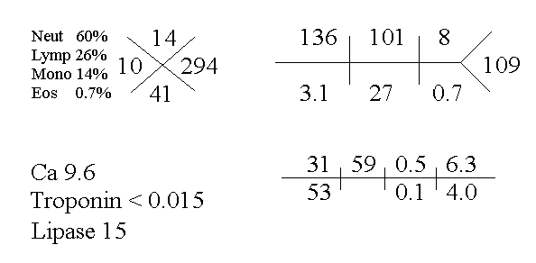

Please see the attached power point file for ECG and radiology.

A diagnostic procedure was performed.

